GreenFaith Circle of Southern New Jersey
We all have our passions: sports teams, classic cars, shoes… One does not normally think of combining secular passions with faith, but if you are passionate about protecting the Earth, here’s an opportunity to do just that.
“Because the Earth and all people are sacred and at risk, GreenFaith is building a worldwide, multi-faith climate and environmental movement. Together our members create communities to transform ourselves, our spiritual institutions, and society to protect the planet and create a compassionate, loving and just world.”
GreenFaith Circles bring together passionate people of faith, conscience and goodwill in a congregation, local faith-based institutions, or a community – offline or online. They are connected to a global Circles network through regular calls, training and campaigns.
The GreenFaith Circle of Southern New Jersey began in 2019, and in its brief existence, has already taken action to limit single-use plastics, has advocated on behalf of the environment with state representatives, and has co-hosted a green jobs educational session.
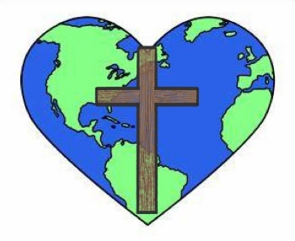
If you are curious about volunteering with an organization that honors your faith and your passion for environmental justice, the GreenFaith Circle of Southern New Jersey is looking for you! Contact us at gfcirclesj@gmail.com

